A guide to IT

- Babblevoice
- Docman
- Emis
- Digi Dictate
- Hardware
- Printer
- Mouse
- Headsets
- Keyboard and Smartcard
- Monitor
- Computer
- Software
- Email
- I have no idea, but it isn’t working

- Babblevoice

What is wrong?-

No one can get onto the system.

If no one can get into the system on the desktop computers, try accessing with a mobile device (e.g. Phone)- go to the Babblevoice website on your browser (Cloud Based Telephony Systems for GP Surgeries | babblevoice) and log into the desktop. If you cannot get in this way, go to Page 5.

If you can access the website on your mobile device and log in, then it is our software jamming access. No-one can really fix this as there is an ongoing dispute between IT and Babble, but take the following steps to ease the impact:

- If the hardphones (deskphones) are still working- go to the ‘Babblevoice console’ on your mobile device, then ‘stuff’.

- Pick the group ‘Group Claremont Reception’ by clicking on the group to highlight, then at the top of the screen in the blue banner click on edit.
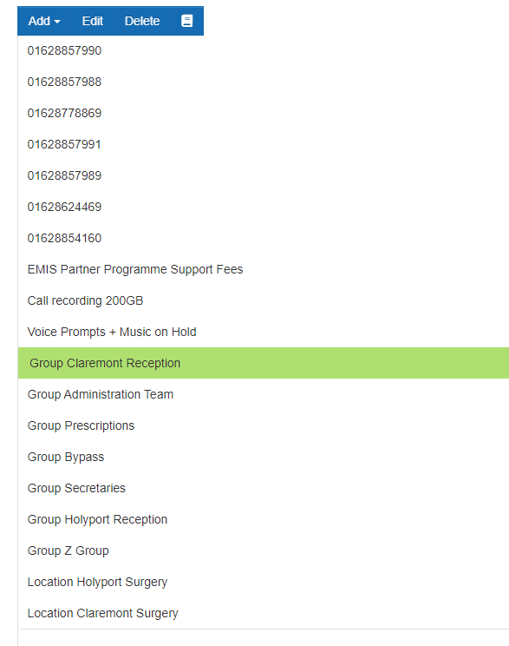
- Add the desk phones to the group (The hardphones state which number they are). Then do the same for ‘Reception Holyport’. You may also need do the same for the Admin team although they normally aren’t affected as often. You may need to add the Emergency Phone at Claremont as there is not a normal desk phone on the day leads desk. On your mobile it is hard to see which phones you have selected in the list- if you turn your screen sideways it is easier to see. Once you are happy with your selection click ‘save and close’ (it’s behind the list, click on the white pace to come out of the list).

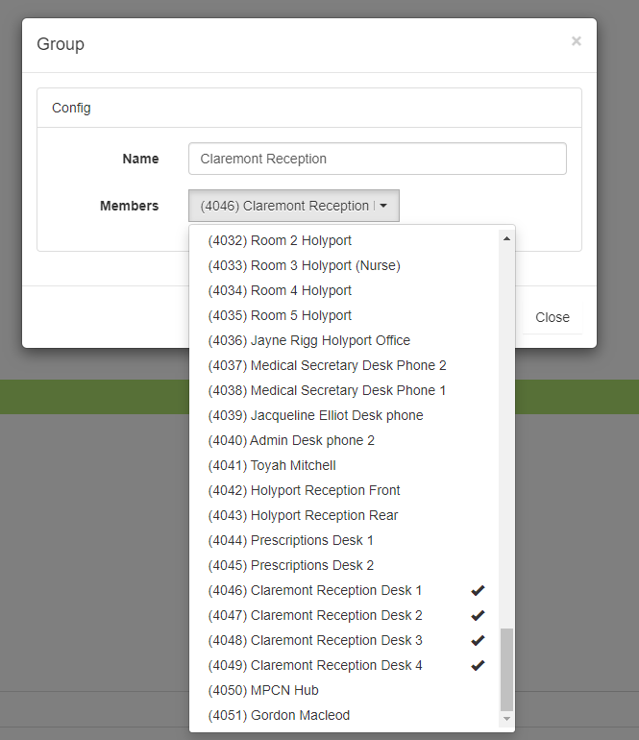
- Please remind reception that once their softphones are back up and running to let you know to put them back in the group and DO NOT PUT ‘DO NOT DISTURB ON’ as this causes calls to get stuck in the system without us knowing until the patient tells us.
- Once the phone groups are sorted go to the computer cupboard on level 4 to reset the WIFI boxes in the computer room and reset the Babblevoice server.

- To reset the server, find the label called ‘this is your Babblevoice server’, at the back of that box directly behind the label is a plug – reach in – you won’t get electrocuted - and pull it out and wait 1 minute then re-plug it in.
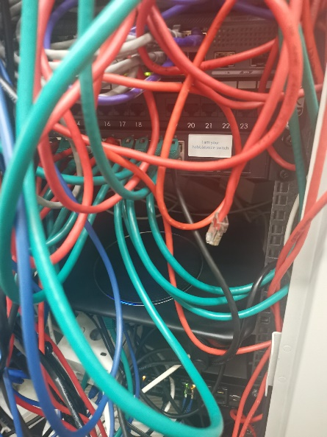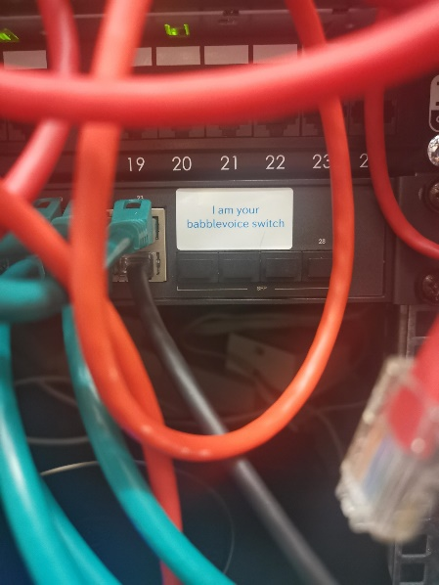

- Reset both routers, one is in the server cupboard and one if on the side next to the PC at the back of the cupboard. Turn off each wifi and turn back on with the button on the back.

- 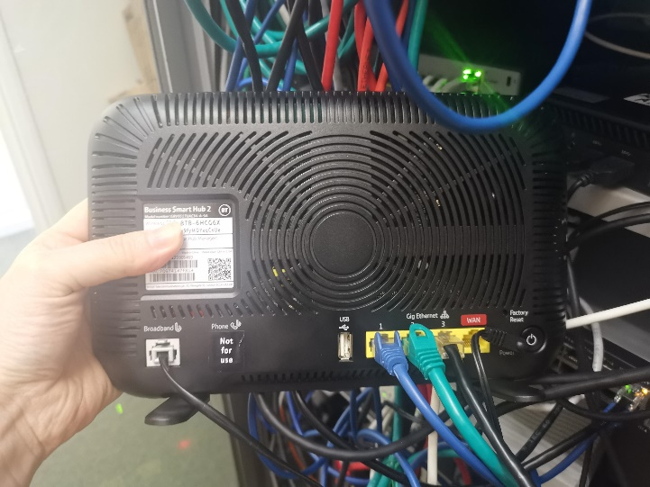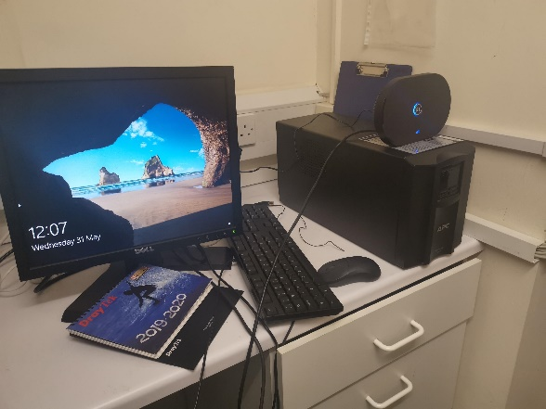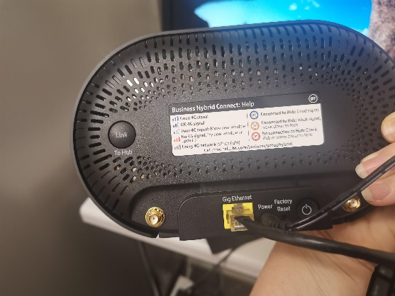
- Once this is done, give the system 20m to recover. The system should resolve the issue itself. If it is not working after 30mins give Babblevoice a call on: 01442 299280 – call them on your mobile and let them know the steps you have taken.

If you cannot access the system through a mobile phone and the Hard phones aren’t working phone Babblevoice on: 01442 299280. They will need to look at the system – I recommend calling them from a mobile as they may need to talk you through doing things in different rooms. If the call does not connect, it means it’s a national issue- email them to say our system is down and they should be in touch: support@babblevoice.com

Things to check if a user is unable to use Babble voice:

- If the name in the box appears as below, try ‘switch to softphone’ in the search:

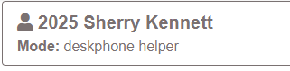
- Is the headset plugged into the computer?
- Is the mute box on the wire turned on.
- Go to ‘google’ check the top right- is it their username?
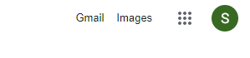
- In google click on the circle with the users initial (as above) in it. Then ‘Manage your account’. Scroll down a little and go to ‘Manage your data and privacy’. Scroll ¾ of the way down to find ‘Your devices’ click on it. This shows all the places the user is logged into their google account (see image below). Click on all of them and ‘sign out’ of this device. Then go back to the initial on the top right and sign out. Then go back to babble and sign in again.
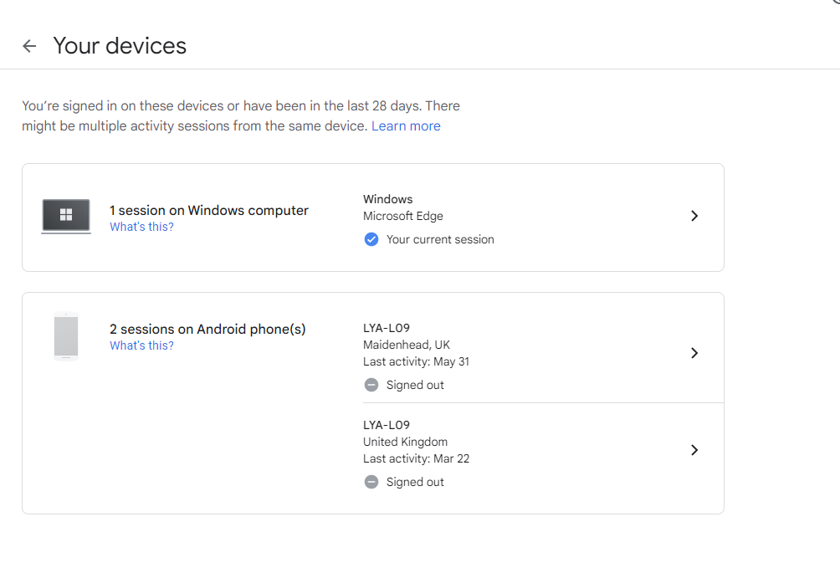
- Check the configure settings.
- ‘reload’ in the search.
- Restart the computer. And try to go back to babble again. (if it is a shared computer and the last person did not log out of windows properly, the current user will not be able to use Babble)
- Phone Babblevoice if all the above doesn’t work.

Other Babble Issues:

Common Problems

Keeps logging you into someone else’s account

If you click on log into Google at the very beginning and it keeps logging you in as someone else's account, then please do the following:
- Go to Internet browser.
- In the search bar type 'Google sign in'
- This will bring up a page which says 'Welcome (first person’s name)'
- On the top right is the persons initial in a circle- click on it
- Then click on 'sign out of all accounts’.
- You then need to log in as your google account (NHS email)
- Then go back to babblevoice to log in- restart the computer if this does not work.
Caller cannot hear call handler.

- First check the box on the wire for your headset, there is a mute button which you may have accidently pressed- the light goes red on the box if this is on.
- If not check the mute on your screen- next to your hang up button if it is red, you are on mute, press it to turn off.
- Try the Headset in a different USB, when you plug it in a little box should pop up at the bottom of the screen acknowledging you have plugged something in.
- Click in the search bar next to the window button on the bottom left of the screen and type in ‘sound’ you can test the mic and audio from there.
- Check the web address box- on the right hand-side and see if there is a little mute symbol with a cross through it? Click on it.

If none of the above could the patient have put you on mute? try calling them back.
Logged in but cannot see the list of internal numbers or not everyone is on there?
Go to: ‘General configure’
Click the box on the right and then click the box on the left with the tick (all the names should be highlighted grey).
Click ‘save and Close’
If this does not work- click in the search box at the top and go to 'Softphone: Switch to Softphone' This will also help if you have the word 'helper' under your name on the top left.

Babblevoice says it cannot connect with EMIS?
Go to the Search bar in Babblevoice and click on 'EMIS General: configure EMIS' (if that choice isn’t there go to ‘General: Plug-in’s’ Choose Emis and click on the little + then go back to configure EMIS)
Enter 14136 in the box at the top labelled 'EMIS CDB Number' then click test connection under the blue box.
A little box should then pop up on your screen saying 'successful'. Then try and call a patient.
If this does not work check EMIS is open.

How to withhold telephone number:

On Babblevoice, where your name is on the top left- click on the little body to the left of your extension number and he will turn into a picture of a spy. Click him again to show caller ID.
How to log in to Babble

Babblevoice should be automatically open on the bottom right-hand side when you log in to your computer, if it doesn’t, please do not click on the icon on windows desktop (blue screen). Instead go to the bottom right of your main screen and click on the blue 'B' Babblevoice icon there- near your clock.

Click on Sign-in to Google- either it will ask you to clarify which account you would like to log in on or it will bring up an internet page which says: 'you may now close this page'. Close the page and then Babblevoice will open.

Once you have Babblevoice open go to the search bar and click on General: Configure.
Then under the 'other phones' box click on the unticked box and then the tick box (right box then the left), this will keep your contact numbers up to date.
Parking lists, Hot desk and Call lists should be on (or green)
Then Theme changes the colour scheme and the megaphone next to the save and close button changes your ringtone.
Once you are happy with your set up click on 'Save and close’.

How to Log out of Babble

This is important if you are on a shared computer.
Click on the padlock at the top of Babblevoice, a few icons to the right of the search bar- this will take you back to the log-on.
Then, right click the Babblevoice icon on the bottom right near the time and right click- them click on Exit and it will disappear from the bar.

Digi problems and Babble

Many of the GP’s have had issues with sound on Digi since we switched to Babble.
You need to adjust the settings in the following ways:
Go to the search bar on windows next to the windows logo/Start button on your computer.
In the search bar type 'Sound' and go to sound settings.
Near the bottom of the page go the toggle just under 'Advanced Sound Options' you will then see your apps at the bottom- change the Digi app (CAC) to 'JPL' for the Audio and 'Speed Mike' on the microphone settings and check the volumes on the app as a lot of them have been turned right down.

Laptops and Babble

Laptops can access the phones without Babble being downloaded, go to the babblevoice website and go to the top right to 'sign in' then select the 'desktop' out of the three drop down options and you can access that way.

If you would like to download the App go to the 'N-drive' on the computer, then 'a-global' file, then Scott Ridley file and the file is called 'bv_desktop_1.1.4.exe'. You then need to call Healthcare computing on 01425 470888. If you cannot find the file either show them these instructions or they can access them through the Babblevoice website."
I have tried everything, and it still isn’t working!

- Turn off the computer (shut down)
- Make a cuppa, exhale, inhale.
- Turn on the computer.
- Log back into everything- Call Babblevoice if it still isn’t working- they are there for support and will be able to take you through step by step, just start the phone call with ‘Sherry isn’t here and I’ve tried to fix it myself’ they wont do it for you but they talk you through it.

- DOCMAN

Docman is pretty straightforward. Tracey Lemon and Jacqui can reset Passwords, or users can reset their own by clicking ‘I have forgotten my password’ although they have normally forgotten their username as well. Both can be accessed under the settings option. If Docman is opened before the user opens EMIS it won’t connect properly, try closing both programmes, open EMIS, then open DOCMAN once EMIS is open.
Other issues users might encounter:
When user clicks on a letter in EMIS it states that the letter cannot be viewed
- Check they have opened Docman 10. If it isn’t open, it won’t work.
- If Docman is open look at the top right of the window, click on Apps and download the desktop app. When it asks for passwords put your own in.
- If it doesn’t download the app call Healthcare computing.
- Restart the computer.
Sometimes workflowers accidently set security on an individual document by mistake speak to level 4 as this cannot be reversed via docman they will need to print and rescan the document on.
- EMIS
If EMIS goes down, if someone is still logged in get them to print the appointment book in-case we lose EMIS completely- Reception know how to do this, do 2 copies- 1 for reception, 1 to be handed out to the clinicians, ensure you tick ‘include patient details’
Worst case scenario clinicians will need to write paper consultations, there is a sheet in the trays on top of the filing cabinet behind my chair. These will then need to be entered into EMIS once the system is up and running again.
Each receptionist will need to be given separate clinician lists to use for calls coming in so they do not book the same slots (eg. Receptionist 1 gets Dr Saraf and Dave, Receptionis 2 gets Dr Viarheichyk and Luke etc.). They should only book in acute issues and advise patients that the clinician will be unable to see their medical history. Try a laptop, they normally don’t work either but worth a try. And remind clinicians that the patients may be able to access their app on their phone which may help.
Report the problem with EMIS Now Login - Customer Support (emisnow.com) through this web page you can view the ‘service status’ which is kept up to date with any known issues, you can click the ‘I’m affected too button’ on this page and they will keep you updated. If there is no relevant open case, you can report an issue under ‘support’ then ‘create a case’ if you have any KD errors include the codes for these as it will help them investigate it.
You will receive an email with updates and eventually a suggestion on how to resolve.

- Digi dictate

Please see page 7 for how to fix sound settings.
Advise the clinician to speak to the secretaries.
If the secretaries have issues advise them to speak to Healthcare computing.
- Hardware
Printer
Printers I get called for most often. Do the following check in this order:
- Is there paper in the bottom tray- fill it anyway some don’t like it when they are less than a quarter full.
- Is there prescription in the top tray, or plain paper- put some in if not.
- Print something yourself and check the user is selecting the right printer (should be reports or top floor photocopier).
- Is there a message on the screen? – If no, check the socket is plugged into the mains.
- If it needs a new toner, take the current toner out, give it a half enthusiastic shake (to avoid coating yourself in ink) put it back in. test it. If it’s still not happy put a new toner in, they are kept in Reception and on level 4. The old toner should have a code on so you know which one to replace it with. Sometimes its trial and error. Put the old toner in the toner recycling box in reception.
- If it needs a new drum, look for boxes with DR- on the side. Some printers you need to hold the green button down for 10secs after replacing the drum. If in doubt, do it anyway. – If the printer is jamming with paper and screwing up pages, replace the drum- if this doesn’t help put the old drum back in and go to the final bullet point.
- If the printer screen says ‘ready’ but isn’t printing when you tell it to- go first to the back of the printer and pull out the power cable and plug it back in. Then the little wire that connects to the computer and plug it back in.
- Next try pulling the printer cable from the back of the PC. I know its like spaghetti junction- follow it back from the printer,
- If none of that works- go to the search bar next to the windows button and type ‘printer’ then click on the printer called reports. Click on ‘open queue’. If it is full of other peoples documents go instead to ‘manage’ then click on trouble-shooter- this should run a diagnostics test and clear any documents and fix any spooler issues. Then test it works.
- If none of the above works, or the issue it that it is trying to drill through the desk when it prints- call Healthcare computing and they either fix it over the phone or they will send a professional
Mouse
- Unplug, then plug back in.
- There is a box of spare in IT cupboard (cardboard box- says ‘mice’ on the side.
Headsets
- There are spare headsets in the IT cupboard on the left as you walk in.
Keyboard and Smartcard
- Tracey Lemon, Jacqui Elliott and Ian nock can unlock smartcards and order new ones.
- National Health Service Portal (ncrs.nhs.uk)
- scwcsu.smartcards@nhs.net to order a new one- include smartcard number and address to be sent to – Claremont or Holyport
- Keyboards- If the system isn’t picking up the smartcard has been put in- pull the keyboard wire out of the computer and pop it back in. firmly.
- There are no new keyboards, there is a keyboard graveyard behind my chair, they may work better, can try them.
Monitor
- Check the wires.
- Again, there are no spare. Call Healthcare computing.
- There are some cables at the back of the computer cupboard,

- Software
There is a GP links menu with links to software which you can install. Alternatively, phone Healthcare computing.
- Email

Either speak to Jayne Rigg who has admin access, or the user needs to call Healthcare computing themselves. We cannot call for them as there are security questions.
- Miscellaneous or not sure
If you are stumped start by calling Healthcare computing, If they cannot fix it, they have all the necessary numbers for you to get to the right person. Alan at Cedars will help also but only if you have tried all other avenues. Anything not urgent get the person to email me and I will resolve it when I get back.

Useful numbers:
DXS Support: 01252 719800
Healthcare Computing: 01425 470888 (option 3)
Babblevoice: 01442299280

Helpful codes:
ODS code K81020
Emis Code 14136
Address: Claremont and Holyport Surgery
2 Cookham Road,
Maidenhead
Berkshire
SL6 8AN
01628 624469

